LOCATION SHEET for R.& J. SAILS
It would be appreciated if visitors could bring clean shoes to wear Unit 2 ( The Loft )
R.& J. SAILS are located in New Road, four minutes from J. 20 of New Road
the M5. As parking is restricted, please telephone before your 42A Kenn Road
visit, to arrange for large or heavy items to be unloaded at Unit 2 CLEVEDON
Parking is either in the “B &M” car park (3 hour limit) or in the North Somerset
(free) long stay car park at “ The Barn “ opposite BS21 6EW
Both car parks, are less than a two minute walk from the sail loft 01275 343585
rjsails@btinternet.com
1. Leave Junction 20 of the M5. From the motorway roundabout travel down Ettlington Way to the large roundabout. Go straight across, following the sign to the “Town Centre”, you are now in Moor Lane.
2. Travel down Moor Lane for 300m to the mini-roundabout. Go straight across into Great Western Road.
3. 50m after the mini-roundabout turn right into the “B&M shoppers” car park ( “The Barn” car park is on the left ) Park as close as possible to the entrance. This is only three minutes from the M5
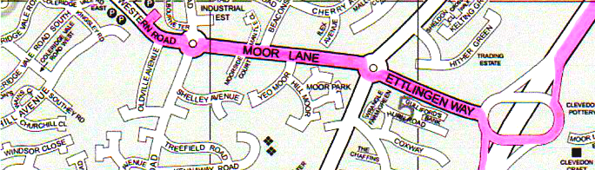

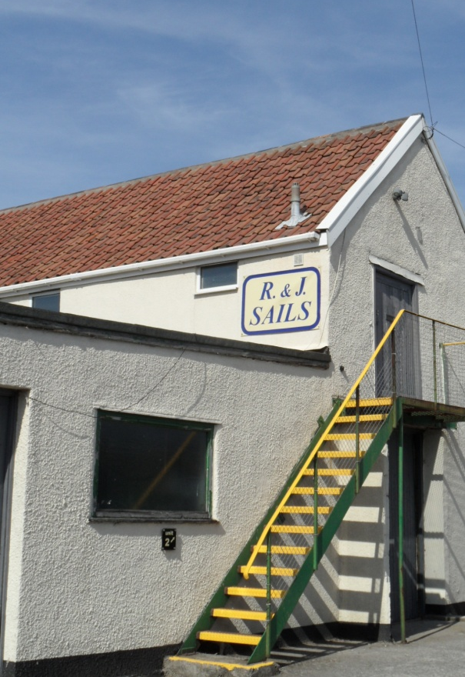
4. Walk back to the mini-roundabout, turn left
into Kenn Road, New Road is a cul-de-sac
20m on your right hand side. BRM Garage
is at the far end. Unit 2 is to the left hand
side of New Road, up the yellow & blue steps.
